August 15, 2019

The Manitoba Construction Sector Council (MCSC) is a not for profit organization that supports new entrants and existing workers in construction with a focus on addressing the needs of underrepresented groups including Indigenous people, youth at risk, women and immigrants. With this in mind, MCSC and our construction association partners including Manitoba Home Builder’s Association, Manitoba Heavy Construction Association, Manitoba Building Trades and Winnipeg Construction Association are hosting a Manitoba Women in Trades Conference on February 18-19th 2020 at Victoria Inn. This event is geared to women who need support, guidance and connections to make their construction career a success.

The purpose of this conference:

- Women will identify challenges and demonstrate effective strategies to work in construction
- Women will be connected to supports available in Manitoba for women in trades
- Employers will demonstrate best practices in the recruitment and retention of women working in construction
- Indigenous women will learn how to overcome challenges to retain employment in the construction industry
- Construction and safety associations, educational institutions, Apprenticeship and construction companies will host a trade show to recruit and market their products and services
- Attendees will network and build relationships to support women in construction
Attendees will include: youth, newcomers, Indigenous women, employers, apprentices and journey people

To make this event happen, we are in need of sponsorship from our industry, education and government partners. With this support, we will be able to bring in the very best presenters and will sponsor women who could not otherwise afford to attend this event.

Topics at the Conference:
1. Employers: Best Practices
2. Indigenous women pathways to construction
3. Newcomers transition to work in Canada
4. Youth- How to get into the trades
5. Supports available for women entering the trades

Attached is a list of potential sponsorship opportunities. Sponsors will have huge marketing opportunities throughout the event! To sponsor the event, visit the event page on www.mbcsc.com after September 3rd. Thank you for your consideration of this request.

Sincerely,
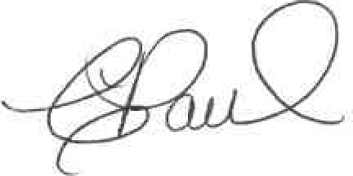
Carol Paul
Executive Director
Manitoba Construction Sector Council
1000 Waverley Street
Winnipeg, MB R3T 0P3
204-272-5092
cpaul@mbcsc.com

